**Creating Microservices for account and loan**

In this hands on exercises, we will create two microservices for a bank. One

microservice for handing accounts and one for handling loans.

Each microservice will be a specific independent Spring RESTful Webservice

maven project having it's own pom.xml. The only difference is that, instead of

having both account and loan as a single application, it is split into two

different applications. These webservices will be a simple service without any

backend connectivity.

**Account:**

**AccountController.java :**

package com.cognizant.account.controller;

import org.springframework.web.bind.annotation.*;

import java.util.Map;

@RestController

public class AccountController {

@GetMapping("/accounts/{number}")

public Map<String, Object> getAccount(@PathVariable String number) {

return Map.of(

"number", number,

"type", "savings",

"balance", 234343

);

}

}

**OUTPUT:**

http://localhost:8081/accounts/0098765432

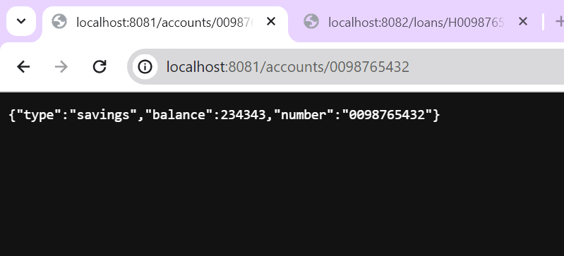

**LoanController.java :**

package com.cognizant.loan.controller;

import org.springframework.web.bind.annotation.*;

import java.util.Map;

@RestController

public class LoanController {

@GetMapping("/loans/{number}")

public Map<String, Object> getLoan(@PathVariable String number) {

return Map.of(

"number", number,

"type", "car",

"loan", 400000,

"emi", 3258,

"tenure", 18

);

}

}

**OUTPUT :**

**http://localhost:8082/loans/H0098765432**

